Final Year Project Synopsis
On
Antimicrobial and dye degradation ability of biologically synthesized nanoparticles along with SEM, TEM, FTIR, and AFM analysis
Under the Guidance of
Dr. Rashmi Mishra
Head of Department
Noida Institute of Engineering and Technology

Presented & Submitted by
Ajay kumar Bhandari- 1613354006
Nikhil kumar Singh-1613354032



Submitted to
Department of Biotechnology
Noida Institute of Engineering & Technology, Greater Noida

Contents
S. No. | Title | Page No.
1. | Introduction and Literature Review | 3
2. | Methodology | 4-7
3. | Work Progress | 8
4. | References | 9

S. No. | Figure Name | Page No.
1. | Plant leaves | 4
2. | Plant extract | 5
3 | Nanoparticles | 5
4 | UV-vis absorbance spectrum of synthesized AgNPs | 6
5 | TEM & TEM image of AgNPs | 7
6 | Culture growth & Agar plates | 7

Introduction
Nanoparticles are the fundamental blocks of nanotechnology with their size ranging b/w 1&100nm.
These are of great interest due to their extremely small size and large surface to volume ratio, which lead to both chemical and physical differences in their properties compared to bulk of the same chemical composition.
For example, the nanoparticles exhibit comparatively varying mechanical, biological, sterical properties and catalytic activity.
There are different types of nanoparticles like silver nanoparticles, gold nanoparticles, copper oxide In the past decade there has been a marked increase in the field of fabrication of nanoparticles with controlled morphologies and remarkable features making it an extensive area of research. The synthesis of nanoparticles (NPs) with control over particle size, shape and crystalline nature has been one of the main objectives in chemistry that could be used for potential applications, such as bio-medical, biosensor, catalyst for bacterial biotoxin elimination and lower cost electrode (Antonyraj et al., 2013, Frances et al., 2009, Staniland, 2007). The nanoparticles (NPs) having at least one dimension less than 100 nm such as nanosheets, nanotubes and nanowires have gained much attention because of their promising applications (Fu et al., 2013, Kwon and Bard, 2012, Roy et al., 2013). Other than their unique physical and chemical properties, NPs act as a bridge between bulk materials and atomic or molecular structures. Therefore, they are good candidate for applications including medical, catalysis, electrochemistry, biotechnology, and trace-substance detection (Luo et al., 2006, Murthy, 2007, Wen et al., 2011, Xia et al., 2013)

Review of literature
Deshpande Raghunandhan (2011) synthesized gold & silver nanoparticles using an aqueous extract of guava leaves and clove buds.
The experimental procedure was to found out the In-vitro anticancer activity against 4 human cell lines.

Sangiliyandi Gurunathan (2013) focused on antitumor potential of AgNPs to the study was determine the cytotoxic effects of AgNPs against the breast cancer particularly MDA-MB-231 breast Cancer cell.

In this experiment culture, supernatant of bacillus funiculus were developed and the silver nanoparticles was characterized by various analytical techniques.
The nature acts like a large “bio-laboratory” comprising of plants, algae, fungi, yeast, etc. which are composed of biomolecules. These naturally occurring biomolecules have been identified to play an active role in the formation of nanoparticles with distinct shapes and sizes thereby acting as a driving force for the designing of greener, safe and environmentally benign protocols for the synthesis of nanoparticles. The present review targets the comparative biogenic synthesis and mechanisms of nanoparticles using algae and waste materials (agro waste in the presence of biomolecules). The use of waste materials not only reduces the cost of synthesis but also minimizes the need of using hazardous chemicals and stimulates ‘green synthesis’. It also focuses on the computational aspects of binding of biomolecules to nanoparticles and some of the applications of the biosynthesized nanoparticles in biomedical, catalysis and biosensors fields.

MATERIALS AND METHOD
Materials:
- Plant leaves extract of Morus (mulburrey), Ficus religiosa(peepal), Azadirachta indica(neem)

Distilled water
- Silver nitrate (AgNO₃)
- Muller Hinton agar
- Nutrient broth
- Bacterial cultures of Escherichia coli

Methods:
Typically, a plant extract-mediated bio reduction of silver nanoparticles involves mixing the aqueous extract with an aqueous solution of the appropriate metal salts.

Preparation of plant extract
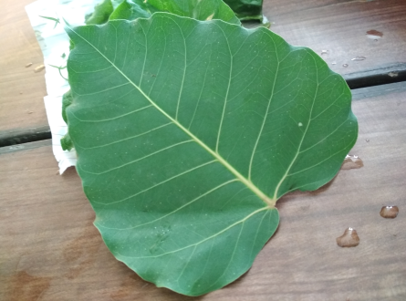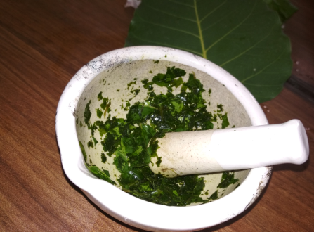
Fig no- 1 plant leaves

Plants like Morus , Ficus religiosa , Azadirachta indica .
Then for surface sterilization first we washed them with running tap water to remove debris and other contaminating organic contents, followed by distilled water and air dried at room temperature for the preparation of plant extract, we used leaves of different.
Then cut them into small fine pieces and crush them into mortar and pestle for desired plant extract.
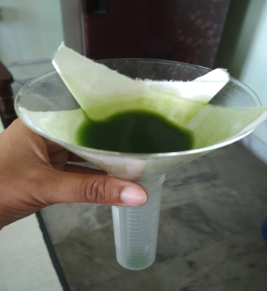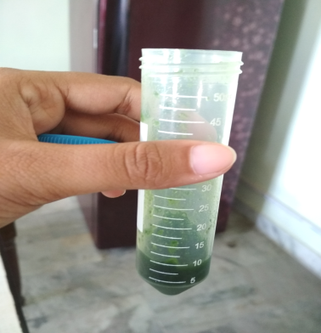
Fig no- 2 plant extract

Then we filtered the extract with Whatman filter paper and stored at 4⁰C for further use.

Preparation of aqueous solution of silver nitrate
1mM solution of silver nitrate is prepared in flask.

Green synthesis of silver nanoparticles
3mL , 4mL, 5mL) in different falcon tube and added separately to 10mL of silver nitrate solution keeping its concentration We took five different concentration of plant extract ( 1mL , 2mL , at 1mM .
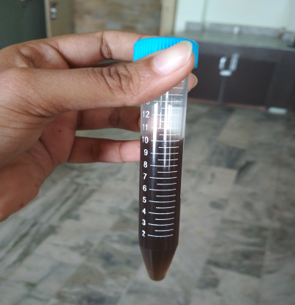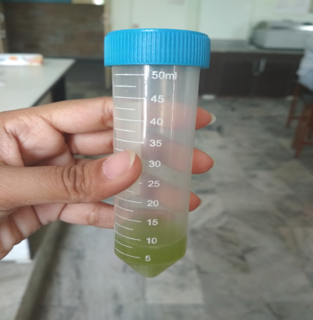
Fig no- 3 nanoparticles

Then cover each falcon tube with foil and kept in a dark room to minimize photo-activation of silver nitrate at room temperature.
Reduction of Ag⁺ to Ag⁰ can be confirmed by the color change of solution from colorless to brown. Its formation should also be confirmed by using UV-Visible spectroscopy.

Characterization of synthesized silver nanoparticles

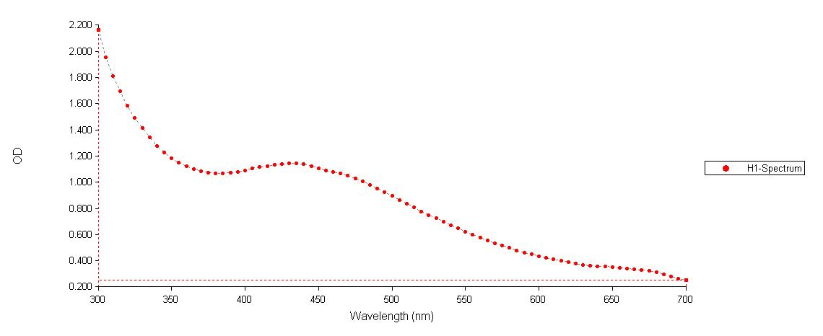
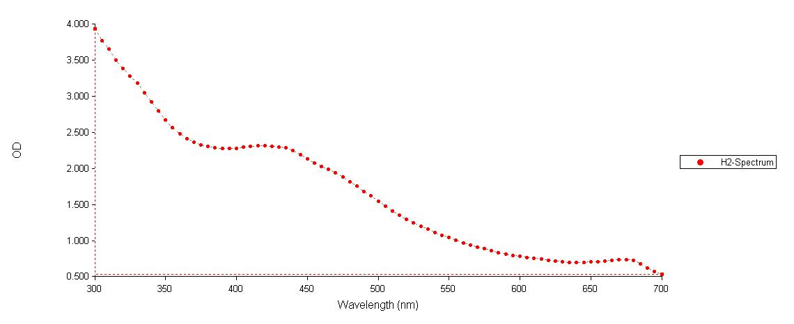
Fig no- 4 UV-vis absorbance spectrum of synthesized AgNPs

UV-Vis spectral analysis was done by using UV-Visible spectrophotometer. One milliliter of the sample was pipette into a test tube and subsequently analyzed at room temperature.
The particle size and surface morphology was analyzed using Scanning Electron Microscopy (SEM) and Transmission Electron Microscopy (TEM).
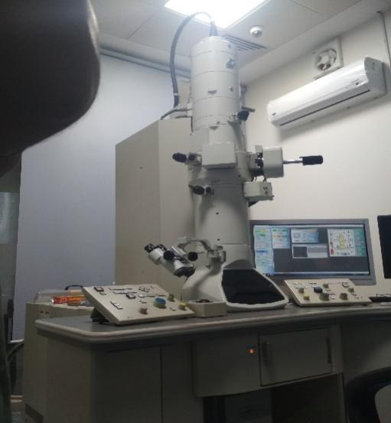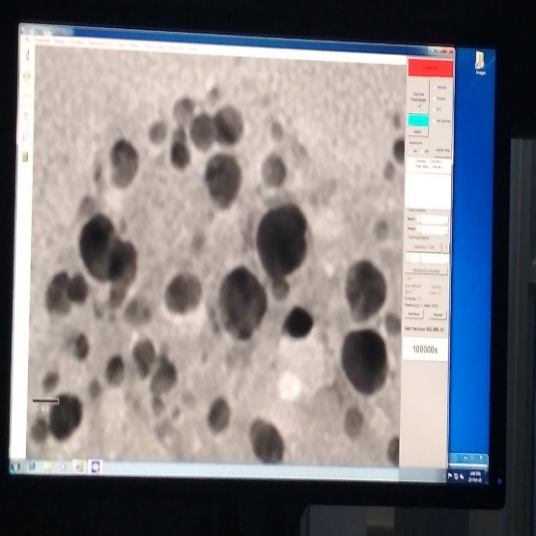
Fig no-5 TEM & TEM image of AgNPs

Screening of antimicrobial activity
Well diffusion method
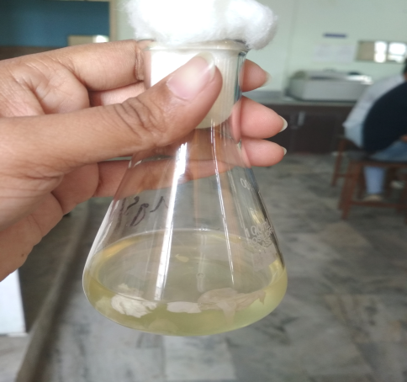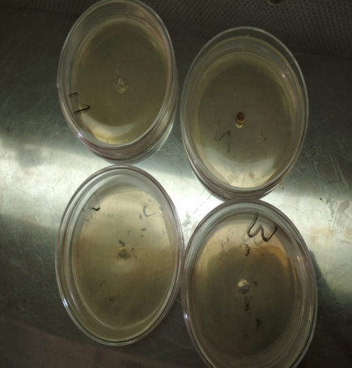e
Fig no-6 culture growth & agar plates

Muller Hinton Agar plates were used and swabbed with pathogenic organisms from fresh cultures (10⁵–10⁶ CFU/mL) using a sterile cotton swab. With the help of sterile gel puncture, approximately 6 mm diameter of wells was made in the agar plates.
Using a micropipette, the drilled wells were poured with 20 μL of the AgNps in concentrations of 50 μg/mL and 100 μg/mL. Separate wells of streptomycin (20 μL, 25 μg/mL) and Morus leaf extract (20 μL) were used in the test as a control for the purpose of comparison. The zone of inhibition was measured after the plates were incubated at 37 °C for 24 h for bacteria and 25 °C for 72 h for fungi.
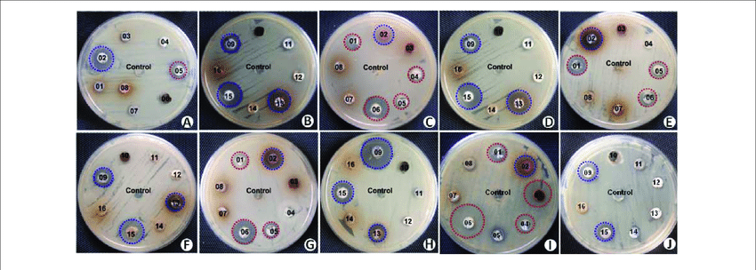

Work Progress Timeline:
Objectives | July 2018 | Aug-Sep 2018 | October  2018 | Nov 2018 | Jan-April  2019
Review of literature and Thesis Writing  initiation | 
Preparation of plant extract & green synthesis of silver nanoparticles. |  | 
UV- vis absorbance spectrum of synthesized silver nanoparticles, and Thesis update. |  |  | 
SEM, TEM analysis of synthesized silver nanoparticles |  |  |  | 
Screening of antimicrobial activity & dye degradation of properties of silver nanoparticles.
Note: The shaded region demarcates the tasks completed

References:
P.P.N., Vijay Kumar, S.V.N., Pammi, Pratap Kollu, K.V.V., Satyanarayana, U., Shameem, 2013. Green synthesis and characterization of silver nanoparticles using Boerhaavia diffusa plant extract and their antibacterial activity. Industrial crops and products, doi:10.1016/ j.indcrop. 2013.10.050
Chauhan, N., Tyagi, A.K., Kumar, P., Malik, A.,(2016). Antibacterial potential of Jatropha curcas synthesized silver nanoparticles against food borne pathogens. Front. Microbiol. 7:1748.doi: 10.3389/fmicb.2016.0178

